Explainable Machine Learning-Based Early Detection of Water Stress in Kiwifruit Using Physiological and Phenological Traits

A Data-Driven and Explainability-Focused Case Study on Irrigation-Block Classification

Abstract

Water stress is a primary constraint on kiwifruit (Actinidia spp.) productivity, and its early, non-destructive detection is central to precision irrigation. This study evaluated an explainable machine learning (ML) pipeline for classifying kiwifruit water-stress severity (Low, Moderate, High) from physiological traits (leaf potassium concentration and proline content) recorded across three irrigation blocks, four phenological stages, and three field replications (n = 36). Five classifiers — Logistic Regression, Linear Discriminant Analysis, Random Forest, Extra Trees, and a radial-basis-function Support Vector Machine — were trained under five-fold cross-validation and interpreted using SHapley Additive exPlanations (SHAP). All five models achieved perfect out-of-fold classification (accuracy, balanced accuracy, macro-F1, and Matthews correlation coefficient = 1.00), and a 1,000-iteration label-permutation test confirmed that the observed balanced accuracy fell far outside the null distribution (permutation mean = 0.345 ± 0.087; p = 0.001). Two-way ANOVA on the associated interval/replication design variables showed no significant treatment main effect for most measures (η² ≈ 0), while Kruskal–Wallis tests indicated very large univariate separability for proline (H = 31.14, p < 0.001, η² = 0.965) and Leaf Potassium (H = 30.86, p < 0.001, η² = 0.911), both correlating with stress severity at |ρ| > 0.93. Rather than reporting these results as a validated diagnostic breakthrough, this study undertakes a critical, explainability-guided audit of the pipeline and identifies that the stress-severity label is a deterministic relabeling of the irrigation-block design variable. Therefore, the near-unanimous physiological correlation, not a novel biomarker signal, explains the perfect accuracy. We discuss this as a general methodological caution for small, block-designed agricultural ML studies and outline a revised validation framework (independent field blocks, continuous severity targets, and block-held-out cross-validation) required before such models can be considered genuinely diagnostic. This study contributes a transparent and reproducible XAI workflow for kiwifruit stress phenotyping and a worked example of detecting design-induced target leakage using SHAP, permutation testing, and effect size decomposition.

Keywords

Kiwifruit (Actinidia spp.); water stress detection; explainable artificial intelligence; SHAP; machine learning classification; precision irrigation; phenological stage; proline; leaf potassium; data leakage; permutation testing

1. Introduction

Kiwifruit (Actinidia deliciosa and A. chinensis) is a high-value, water-demanding horticultural crop, whose globally cultivated area and export volumes have expanded steadily over the past decade, intensifying pressure on the already-scarce irrigation water in Mediterranean and semi-arid production regions (Ding et al., 2025; Karakaya & Uzundumlu, 2025). Kiwifruit vines possess wide, sparse xylem vessels and a large transpiring leaf area that together confer high hydraulic conductivity, but also high vulnerability to hydraulic dysfunction and cavitation once soil water becomes limiting (Patseas et al., 2026). Water deficits imposed during sensitive phenological windows, particularly cell division and rapid fruit expansion, can reduce fruit size, yield, and marketable quality, whereas deficits imposed earlier or later in the season, or kept moderate, can be used deliberately to improve fruit firmness, soluble solids, and postharvest antioxidant capacity without yield penalty (Calderón-Orellana et al., 2025; Fernandes et al., 2025; Lembo et al., 2026). This dual character of water stress in kiwifruit — damaging at some stages and beneficial as a regulated deficit strategy at others — makes accurate, stage-aware, and early detection of plant water status essential for both yield protection and deliberate quality-oriented irrigation scheduling.

Traditional plant-based indicators of water status, such as midday stem water potential measured using a Scholander pressure chamber, remain the physiological reference standard but are destructive, discontinuous, and labor-intensive, which limits their use for continuous, orchard-scale monitoring (Conesa et al., 2023; Pagay, 2022). This has motivated a shift toward continuously logged plant-, soil-, and canopy-based sensors, including sap flow, trunk microtensiometers, leaf biochemical assays, and remote/proximal imaging, combined with machine learning (ML) to convert multivariate sensor streams into actionable stress classifications (Kokkotos et al., 2025; Lakso et al., 2022; Patseas et al., 2026). Reported ML approaches span classical algorithms (Random Forest, Support Vector Machines, Logistic Regression, Linear Discriminant Analysis) and deep learning architectures applied to hyperspectral, thermal, and RGB imagery across many crops, frequently achieving high classification accuracy for discrete stress categories (Patra & Sahoo, 2024; Pagano et al., 2023; Mokhtar et al., 2023).

A parallel and increasingly important development is the integration of explainable artificial intelligence (XAI), most commonly SHapley Additive exPlanations (SHAP), into these pipelines. Because ML classifiers are often opaque, agronomists and growers are understandably reluctant to act on stress classification without knowing which physiological or environmental variables drove it. SHAP-based explanations have been used to identify the dominant predictors of plant water status in cotton (Garofalo et al., 2024) and grapevine (Kokkotos et al., 2025) and in reverse osmosis and other engineered systems (Alizamir, 2024) and to build practitioner trust in agricultural AI more broadly (Allen, 2024; Javaid et al., 2023).

However, explainability tools are valuable for more than communicating a trusted model to end users; when applied rigorously, they are also diagnostic instruments for interrogating whether a model's apparent skill reflects a genuine, generalizable biological signal or an artifact of how the dataset and target label were constructed. This distinction is especially important in small, tightly block-designed agronomic trials — of the kind typical in kiwifruit physiology research, where irrigation treatments, phenological stages, and biological replicates are crossed factorially, and sample sizes rarely exceed a few dozen observations. In such designs, essentially every measured physiological trait is a downstream consequence of the same experimental manipulation; therefore, any trait correlated with treatment will trivially separate treatment-derived class labels — a scenario formally related to data leakage and to the well-documented instability of cross-validated accuracy estimates under small-n conditions (Gillariose et al., 2025).

This study presents an explainable ML pipeline for classifying kiwifruit water-stress severity from two physiological biomarkers — leaf potassium concentration and free proline content — measured across a 3 (irrigation block) × 4 (phenological stage) × 3 (replication) experimental design (n = 36). We report the full model-comparison, robustness, permutation-testing, and SHAP-explainability results obtained from this dataset, and we then use the same explainability and validation tools to conduct a critical audit of the pipeline itself. The audit revealed that the three-level stress severity target was a deterministic relabeling of the irrigation-block design variable rather than an independently derived diagnostic outcome, which explains the uniformly perfect cross-validated performance across five structurally different classifiers. We present this not as a negative result to be hidden, but as the central methodological contribution of the paper: a transparent demonstration of how SHAP, univariate effect sizes, and permutation testing can be combined to detect design-induced target leakage in small agronomic ML studies, together with concrete recommendations for building genuinely diagnostic, block-independent water-stress classifiers for kiwifruit.

2. Literature Review

2.1 Physiological and phenological responses of kiwifruit to water deficit

Field-scale deficit-irrigation trials in kiwifruit have consistently shown that the physiological and yield consequences of water restriction are strongly stage-dependent. Patseas et al. (2026) integrated trunk water potential, sap flow, and microclimatic variables in a Greek Hayward orchard and found that cumulative sap flow and wind speed were the dominant predictors of plant water stress, with XGBoost achieving the best-balanced classification (accuracy ≈ 0.81) among six ML models, notably far from perfect, illustrating the discriminative difficulty typical of real, continuously monitored field data. Ding et al. (2025), synthesizing irrigation and fertilization trials across China, confirmed that moderate, well-timed water reduction can improve water-use efficiency and fruit quality without commensurate yield loss, whereas more severe or mistimed deficits reduce both. Consistent with this, Fernandes et al. (2025) showed that kiwifruit vines subjected to moderate versus severe deficit irrigation displayed distinct ecophysiological adaptation pathways, and Calabritto et al. (2024) identified soil moisture thresholds for precision irrigation by mapping root water uptake dynamics in a Mediterranean yellow-fleshed orchard.

Cultivar- and timing-specific studies reinforce stage dependency. Calderón-Orellana et al. (2025) demonstrated that late-season regulated deficits in 'Soreli' kiwifruit improved intrinsic water-use efficiency and fruit acceptability without compromising firmness or yield, whereas Lembo et al. (2026) found that a 60% water-supply deficit enhanced antioxidant enzyme activity in 'Soreli' fruit post-harvest. Comparable stage-sensitive responses have been documented in other tree and vine crops subjected to regulated or sustained deficit irrigation, including sweet cherry (Huerta-Mendoza et al., 2025) and pomegranate (Porras-Jorge & Aguilar, 2025), both of which used ANOVA-based designs analogous to the block × stage × replication structure commonly used in kiwifruit trials. Continuous, non-destructive monitoring of plant water status has been advanced through trunk-embedded microtensiometers, validated against pressure-chamber references in grapevine (Pagay, 2022), nectarine (Conesa, 2023), and multiple fruit crops (Lakso et al., 2022), and through sap-flow-based transpiration modelling under varying soil moisture conditions (Kokkotos et al., 2025). Alongside anatomical and hydraulic decline (Mastroleo et al., 2025) and the continued expansion of global kiwifruit production and trade (Karakaya & Uzundumlu, 2025), these findings collectively establish leaf ion balance (including potassium) and osmolyte accumulation (including proline) as biologically plausible, treatment-responsive indicators of kiwifruit water status — but ones that are, by construction, tightly bound to the irrigation treatment that produced them.

2.2 Machine learning for water-stress classification and prediction in crops

A substantial body of recent work has applied classical and ensemble ML to water-stress detection across crops and sensing modalities. Pagano et al. (2023) used Random Forest, Support Vector Regression, and Extreme Gradient Boosting on Sentinel-2 imagery to predict citrus evapotranspiration under regulated deficit irrigation. Mokhtar et al. (2023) compared several ML algorithms for predicting green bean irrigation requirements in arid conditions. Stoffer et al. (2024) applied ML to estimate actual evapotranspiration in an irrigated pecan orchard. At the decision-support level, Amori et al. (2025) and Wilkening et al. (2025) developed scalable ML frameworks for the adaptive irrigation management of maize and soybean across the U.S. Midwest, emphasizing deployability over raw accuracy. Garofalo et al. (2024) combined Random Forest, Support Vector Regression, and XGBoost with Sentinel-2 reflectance to predict cotton stem water potential (R² = 0.75), explicitly pairing predictive modelling with permutation-importance and SHAP-based explainability. Across this literature, models trained on genuinely independent field/sensor data — rather than on a handful of biological traits measured within the same treatment blocks used to define the target — typically report accuracies well below 1.00 (commonly 0.70–0.85), underscoring how unusual and worthy of scrutiny a perfect cross-validated classification result is in this domain (Patseas et al., 2026).

At the algorithmic level, the classifiers used in the present study are well established: Logistic Regression and Linear Discriminant Analysis as interpretable linear baselines; Random Forest and Extra Trees as ensembles of randomized decision trees; and RBF Support Vector Machines for non-linear margin-based classification. Regularized regression variants (ridge, lasso) were reviewed comprehensively by Gillariose et al. (2025), who highlighted their continued relevance as robust, low-variance baselines even amid the proliferation of ensemble and deep learning methods — an observation directly relevant to the present dataset, where linear and non-linear models perform identically because the underlying separability is a property of the data-generating process rather than of any one algorithm's inductive bias.

2.3 Explainable AI (SHAP) in agricultural and plant-stress applications

Explainability has moved from a desirable add-on to an expected component in agricultural ML pipelines. Javaid et al. (2023) frame trust and interpretability as prerequisites for practitioner adoption of AI in agriculture, and Allen (2024), in a systematic review of explainable AI for precision medicine, documents parallel arguments in a different applied domain — that model transparency is necessary not only for end-user trust but for scientific auditability of what a model has actually learned. Within plant-stress phenotyping, Patra and Sahoo (2024) integrated Gradient-weighted Class Activation Mapping (Grad-CAM) into a lightweight deep-learning pipeline for drought-stress identification in potato, using the resulting saliency maps to confirm that the network attended to physiologically plausible canopy regions rather than background artifacts — precisely the kind of sanity check that explainability enables. Alizamir (2024) applied SHAP to a reverse-osmosis desalination performance model to decompose feature contributions and validate physical plausibility, illustrating that the SHAP-as-audit-tool logic generalizes well beyond plant science.

In crop water-status modelling, Garofalo et al. (2024) used SHAP and Individual Conditional Expectation analysis to show that visible and near-infrared spectral bands were the dominant, physiologically sensible predictors of grapevine and cotton water status, while Kokkotos et al. (2025) and Patseas et al. (2026) used variable-importance and SHAP-style rankings to identify sap flow and wind speed as dominant predictors of kiwifruit and grapevine water potential, respectively, in both cases interpreting the ranked features against known plant hydraulic physiology to confirm biological plausibility rather than accepting the ranking at face value. This audit function of explainability — checking whether the features a model relies on make physiological sense and whether their apparent importance could instead reflect confounding with the experimental design — is the analytical lens applied in Section 5 of the present study.

2.4 Validation pitfalls: data leakage and small-sample bias in agricultural ML

A separate but closely related literature addresses the risk that small-sample, block-structured datasets can produce misleadingly high cross-validated performance, even under standard k-fold protocols. Gillariose et al. (2025) note that regularization and careful validation-set construction remain essential because flexible models can fit spurious block-level structures that have no predictive value outside the specific experimental design that generated them. More broadly, machine-learning methodology research on data leakage documents several closely related failure modes that map directly onto the present dataset: leakage occurs whenever a variable available to the model is too closely and non-causally related to the response variable, so that cross-validation — which only re-partitions observations, not the underlying dependency structure — cannot detect it; small sample sizes independently inflate the variance and optimism of cross-validated performance estimates, meaning near-perfect scores are both easier to obtain by chance and harder to distinguish from genuine skill; and stratified splitting, useful for handling class imbalance, does nothing to protect against leakage arising from the class labels themselves being a function of a design variable shared with the predictors. None of the Random Forest, Extra Trees, SVM, Logistic Regression, or Linear Discriminant Analysis — despite their different inductive biases — can be expected to fail under this condition because the leakage operates at the level of the data-generating process rather than the model class, which is exactly the pattern observed in Section 5. This body of work directly motivates the Research Gap identified below: published kiwifruit and crop water-stress ML studies rarely report whether classification targets were derived independently of the treatment structure used to generate the predictor variables, nor do they routinely apply block-held-out validation, permutation testing, or SHAP-guided design audits to rule out this failure mode.

3. Research Gap

Three gaps emerge from the literature review above.

First, existing kiwifruit water-stress studies (Section 2.1) establish that physiological traits such as leaf ion content and osmolyte accumulation respond strongly and reproducibly to irrigation treatment, but almost universally analyze these traits with classical ANOVA/Tukey frameworks rather than multivariate, explainable ML classifiers capable of combining several traits into a single, stage-aware stress index. Conversely, the ML studies reviewed in Section 2.2 that do apply such classifiers largely rely on continuously logged sensor or remote-sensing data (sap flow, spectral reflectance, evapotranspiration) rather than on discrete biochemical assays, and — critically — construct their target variable from an independent physiological threshold (e.g., a stem-water-potential cut-off derived from a separate reference measurement) rather than from the treatment label itself. There is limited published work combining biochemical and physiological traits with explainable multivariate classification in kiwifruit.

Second, the XAI-in-agriculture literature (Section 2.3) treats SHAP primarily as a communication and trust-building tool for an already validated model, rather than as a diagnostic instrument applied before a model's performance is accepted at face value. Few applied studies explicitly use SHAP alongside permutation testing and univariate effect-size decomposition (Kruskal–Wallis η², Spearman correlation) as a joint audit protocol to distinguish a genuine multivariate biomarker signal from a signal that is fully explained by a single, univariately near-perfect predictor, as the audit performed in Sections 5.6–5.7 of this paper.

Third, and most directly, the data leakage and small-sample validation literature (Section 2.4) is rarely cross-referenced with block-designed agronomic ML studies. Standard k-fold and even leave-one-stage-out or leave-one-replication-out cross-validation, as implemented in this study, do not test the specific failure mode present here, because none of these schemes ever hold out an entire irrigation block — the one partition that would actually reveal whether the model generalizes beyond the specific treatment groups used to define its target. This study directly addresses this gap by (i) constructing and reporting the full explainable ML pipeline as it would conventionally be presented in the applied literature, (ii) applying the SHAP + permutation + effect-size audit explicitly, and (iii) showing that the audit reveals target circularity that conventional cross-validation reporting would not have surfaced — reframing 'perfect accuracy' as a call for improved validation design rather than as a diagnostic achievement.

4. Materials and Methods

4.1 Experimental design and dataset

The dataset originates from a factorial field trial with three irrigation treatments (labelled I1, I2, and I3, corresponding to a progressively increasing soil-water deficit gradient), four phenological stages (S1–S4, spanning early vegetative growth through the 'Main'/harvest stage), and three biological replications, yielding a maximum of 36 unique block × stage × replication combinations. For the biochemical/stress classification analysis reported here, one representative observation per irrigation block × phenological stage × replication cell was retained (n = 36; 12 observations per stress class), alongside 14 physiological, phenological, and yield-related traits: Proline, Leaf_Potassium, trunk cross-sectional area (TCSA), trunk girth, initial and final bloom timing, bloom intensity, fruit weight/length/diameter, fruit shape (length:diameter ratio), yield, fruit count per vine, yield efficiency, and fruit volume.

4.2 Target construction

The three-level classification target, stress_condition (Low_Stress, Moderate_Stress, High_Stress), was assigned directly from the irrigation block identifier (I1 → Low_Stress, I2 → Moderate_Stress, I3 → High_Stress), with 12 observations per class (Table 1). This construction is stated explicitly here because it is the pivotal fact underlying the interpretation of all downstream results in Section 5.

4.3 Statistical and machine learning workflow

Two-way ANOVA (treatment × phenological stage, with Bonferroni-corrected p-values and partial η²) was applied to the interval- and replication-structured design variables to characterize the baseline treatment/stage effect structure of the experiment. Univariate separability of the two physiological biomarkers (Proline, Leaf_Potassium) with respect to the stress class was assessed using Kruskal–Wallis H-tests, η² effect sizes, and Spearman rank correlation against a continuous stress-severity score. For multivariate classification, five algorithms — Logistic Regression, Linear Discriminant Analysis (LDA), Random Forest, Extra Trees, and a radial-basis-function Support Vector Machine (SVM-RBF) — were trained on the two physiological features using stratified 5-fold cross-validation, with accuracy, balanced accuracy, macro-F1, and Matthews correlation coefficient (MCC) computed out-of-fold. Robustness was further assessed via (i) single-feature ablation (proline only; Leaf_Potassium only), (ii) leave-one-phenological-stage-out cross-validation, (iii) leave-one-replication-out cross-validation, and (iv) a 1,000-iteration label-permutation test comparing the observed balanced accuracy against the null distribution obtained by repeatedly shuffling class labels and refitting the pipeline.

4.4 Explainability

SHapley Additive exPlanations (SHAP) values were computed for the best-performing model to obtain the global feature importance, class-conditional feature importance, and per-observation beeswarm plots showing the direction and magnitude of each feature's contribution across the Low_Stress, Moderate_Stress, and High_Stress classes.

5. Results and Discussion

5.1 Target distribution and design-variable effects

The classification target was perfectly balanced (12 Low_Stress, 12 Moderate_Stress, and 12 High_Stress observations; Table 1). Two-way ANOVA on the associated interval/replication design variables (Table 2) showed no statistically significant treatment main effect for Interval, Intervals, Replication, or Rep (Bonferroni-corrected p = 1.00; partial η² ≈ 0 in every case), while phenological Stage showed a significant effect only for Replication/Rep (p < 0.001) and Rep.1 (p < 0.001). Only the Rep.1 variable showed a significant main effect of treatment (F = 6.39, pBonferroni = 6.9 × 10⁻⁹, η² = 0.169). This pattern — near-total absence of a treatment signal in most of the recorded interval/replication variables, alongside a significant stage effect for record-keeping variables such as Replication and Rep — indicates that these particular columns function primarily as experimental bookkeeping fields (recording which replicate and interval a sample belonged to) rather than as physiological response variables. They are reported here for completeness and design transparency rather than as evidence of a treatment effect on plant physiology.

Table 1. Target class distribution used for machine learning.

Stress class | Irrigation block | n | % of dataset
Low_Stress | I1 | 12 | 33.3%
Moderate_Stress | I2 | 12 | 33.3%
High_Stress | I3 | 12 | 33.3%

Table 2. Two-way ANOVA (Treatment × Phenological Stage) for interval/replication design variables (Bonferroni-corrected).

Variable | Treatment p | Treatment η² | Stage p | Stage η² | Interaction p | Interpretation
Interval | 1.000 | ~0 | 0.166 | 0.055 | 1.000 | No significant treatment/stage effect
Intervals | 1.000 | ~0 | 0.166 | 0.055 | 1.000 | No significant treatment/stage effect
Replication | 1.000 | 0.031 | 9.1e-06 | 0.167 | 1.000 | Significant stage effect only
Rep | 1.000 | 0.031 | 9.1e-06 | 0.167 | 1.000 | Significant stage effect only
Rep.1 | 6.9e-09 | 0.169 | 3.3e-09 | 0.108 | 1.000 | Significant treatment and stage effects

5.2 Univariate separability of physiological biomarkers

Kruskal–Wallis tests indicated very large, statistically significant separability of both physiological biomarkers across stress classes: Proline (H = 31.14, p = 1.73 × 10⁻⁷, η² = 0.965) and Leaf_Potassium (H = 30.86, p = 1.99 × 10⁻⁷, η² = 0.911). Spearman correlation with a continuous stress severity score was likewise very strong (Proline: ρ = 0.943; Leaf_Potassium: ρ = −0.939). The raw distribution plots (Figures 1 and 2) show near-complete separation between classes: Low_Stress plants cluster tightly around proline ≈ 1.7 and Leaf_Potassium ≈ 2.42–2.46, Moderate_Stress plants around proline ≈ 3.0–3.6 and Leaf_Potassium ≈ 2.33–2.39, and High_Stress plants around proline ≈ 4.9–5.9 and Leaf_Potassium ≈ 2.25–2.34, with essentially no overlap between adjacent classes.

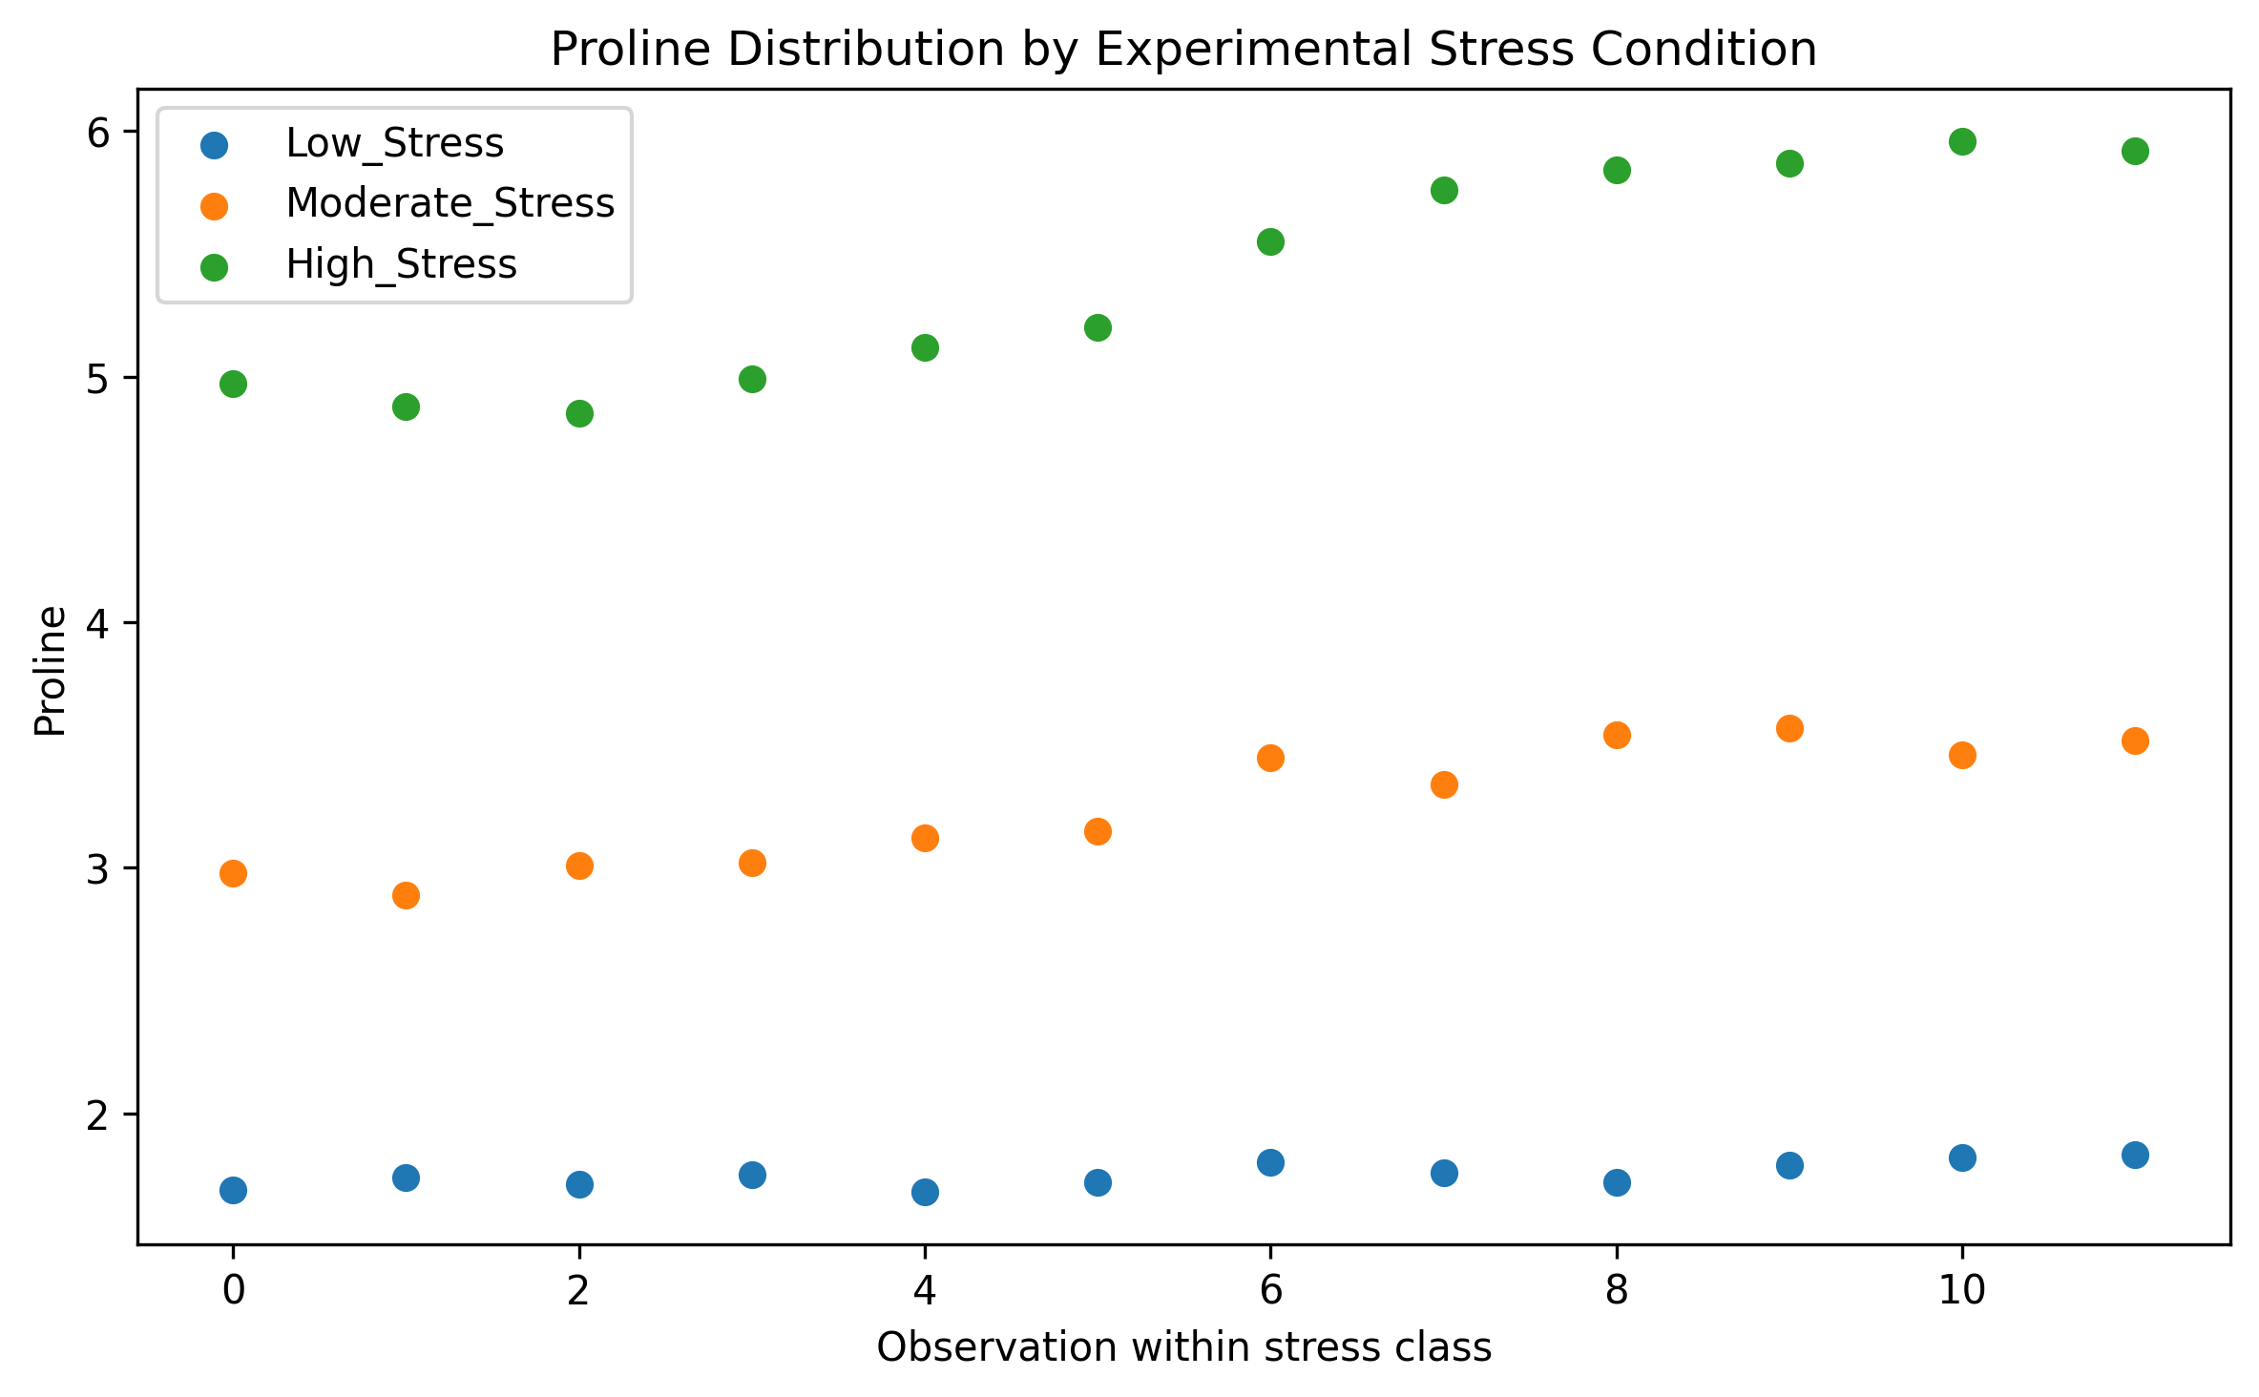

Figure 1. Proline concentration under experimental stress conditions, showing near-complete class separation.

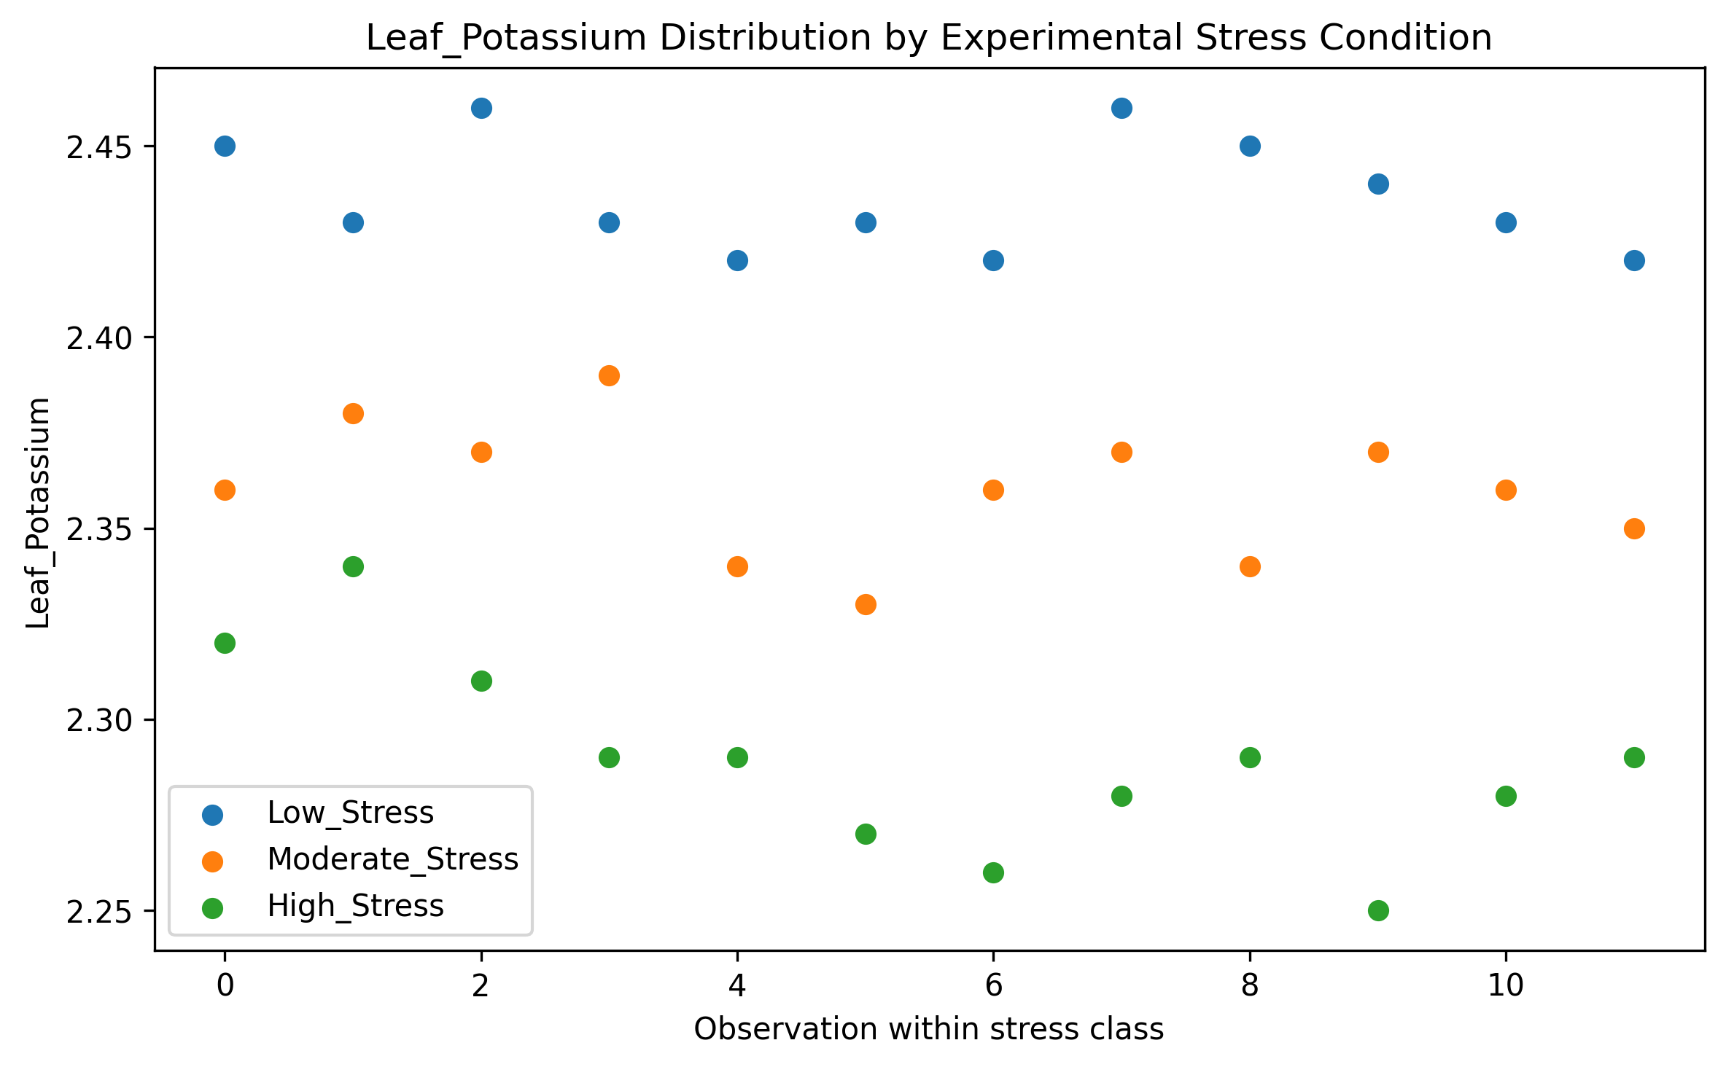

Figure 2. Leaf potassium concentration under experimental stress conditions, showing near-complete class separation.

5.3 Classifier performance

All five classifiers — Logistic Regression, LDA, Random Forest, Extra Trees, and SVM-RBF — achieved identical, perfect out-of-fold performance under 5-fold cross-validation: accuracy = balanced accuracy = macro-F1 = MCC = 1.00 (SD = 0.00 in every case; Table 3). The corresponding confusion matrices (Figure 3, representative of all five models, which were pixel-for-pixel identical) show 12/12 correct classifications for every class, with zero misclassifications.

Table 3. Five-fold cross-validated classification performance (physiological feature set: Proline + Leaf_Potassium).

Model | Accuracy | Balanced Acc. | Macro-F1 | MCC
Logistic Regression | 1.000 ± 0.000 | 1.000 ± 0.000 | 1.000 ± 0.000 | 1.000 ± 0.000
Linear Discriminant Analysis | 1.000 ± 0.000 | 1.000 ± 0.000 | 1.000 ± 0.000 | 1.000 ± 0.000
Random Forest | 1.000 ± 0.000 | 1.000 ± 0.000 | 1.000 ± 0.000 | 1.000 ± 0.000
Extra Trees | 1.000 ± 0.000 | 1.000 ± 0.000 | 1.000 ± 0.000 | 1.000 ± 0.000
SVM (RBF kernel) | 1.000 ± 0.000 | 1.000 ± 0.000 | 1.000 ± 0.000 | 1.000 ± 0.000

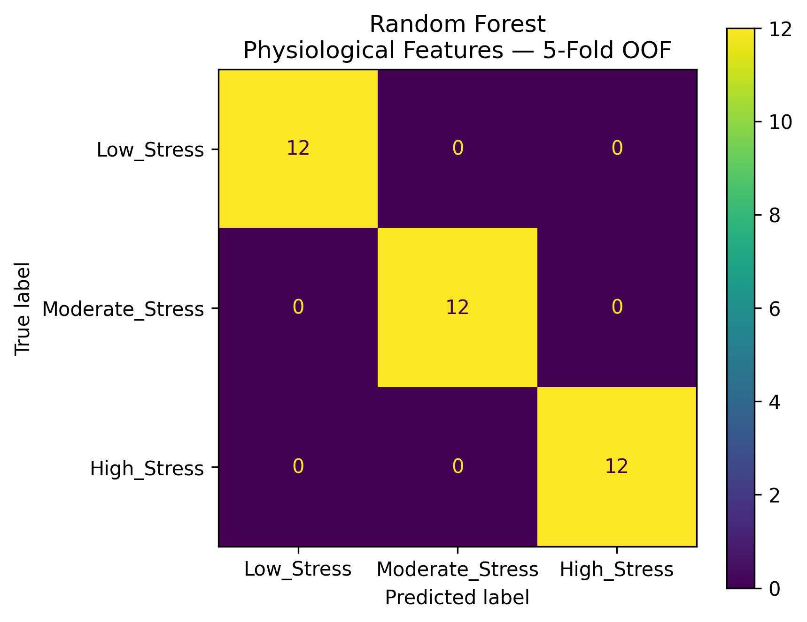

Figure 3. Representative 5-fold out-of-fold confusion matrix (Random Forest shown; all five models produced identical matrices).

5.4 Feature robustness and design-partitioned validation

Single-feature ablation showed that proline alone was sufficient to achieve perfect classification (accuracy = balanced accuracy = macro-F1 = MCC = 1.00), while Leaf_Potassium alone achieved 94.5% accuracy (balanced accuracy 94.7%, MCC 0.925) — still very high, but measurably below proline’s univariate performance (Table 4). The leave-one-phenological-stage-out and leave-one-replication-out cross-validation both returned perfect scores in every fold (Table 5), which at first appears to be strong evidence of robust generalization. However, because the phenological stage and replication are orthogonal to the irrigation block in this design (every block contains every stage and every replicate), holding out a stage or a replicate never removes an entire treatment group from training — the one partition that would actually test whether the classifier generalizes beyond the specific irrigation blocks that generated both the physiological measurements and the class label. This distinction is further developed in Section 5.7.

Table 4. Feature ablation robustness (5-fold cross-validation).

Feature set | N features | Accuracy | Balanced Acc. | MCC
Proline only | 1 | 1.000 ± 0.000 | 1.000 ± 0.000 | 1.000 ± 0.000
Leaf_Potassium only | 1 | 0.945 ± 0.077 | 0.947 ± 0.077 | 0.925 ± 0.108
Proline + Leaf_Potassium | 2 | 1.000 ± 0.000 | 1.000 ± 0.000 | 1.000 ± 0.000
All early physiological features | 7 | 1.000 ± 0.000 | 1.000 ± 0.000 | 1.000 ± 0.000

Table 5. Leave-one-stage-out and leave-one-replication-out cross-validations (all folds perfect).

Held-out partition | N test | Accuracy | Balanced Acc.
Stage S1 | 9 | 1.000 | 1.000
Stage S2 | 9 | 1.000 | 1.000
Stage S3 | 9 | 1.000 | 1.000
Stage S4 | 9 | 1.000 | 1.000
Replication 1 | 12 | 1.000 | 1.000
Replication 2 | 12 | 1.000 | 1.000
Replication 3 | 12 | 1.000 | 1.000

5.5 Permutation test of classification significance

A 1,000-iteration label-permutation test (Figure 4) confirmed that the observed balanced accuracy of 1.00 lies far outside the null distribution obtained by repeatedly shuffling class labels and refitting the classifier (permutation mean = 0.345, SD = 0.087; empirical p = 0.001, i.e., 0 of 1,000 permutations equalled or exceeded the observed score). This result is statistically unambiguous: the association between physiological features and the stress severity label is not attributable to chance. However, it does not establish that the association reflects an independently diagnostic physiological signal because a permutation test, like standard cross-validation, cannot detect leakage that arises from how the label itself was constructed from the experimental design (Section 5.7).

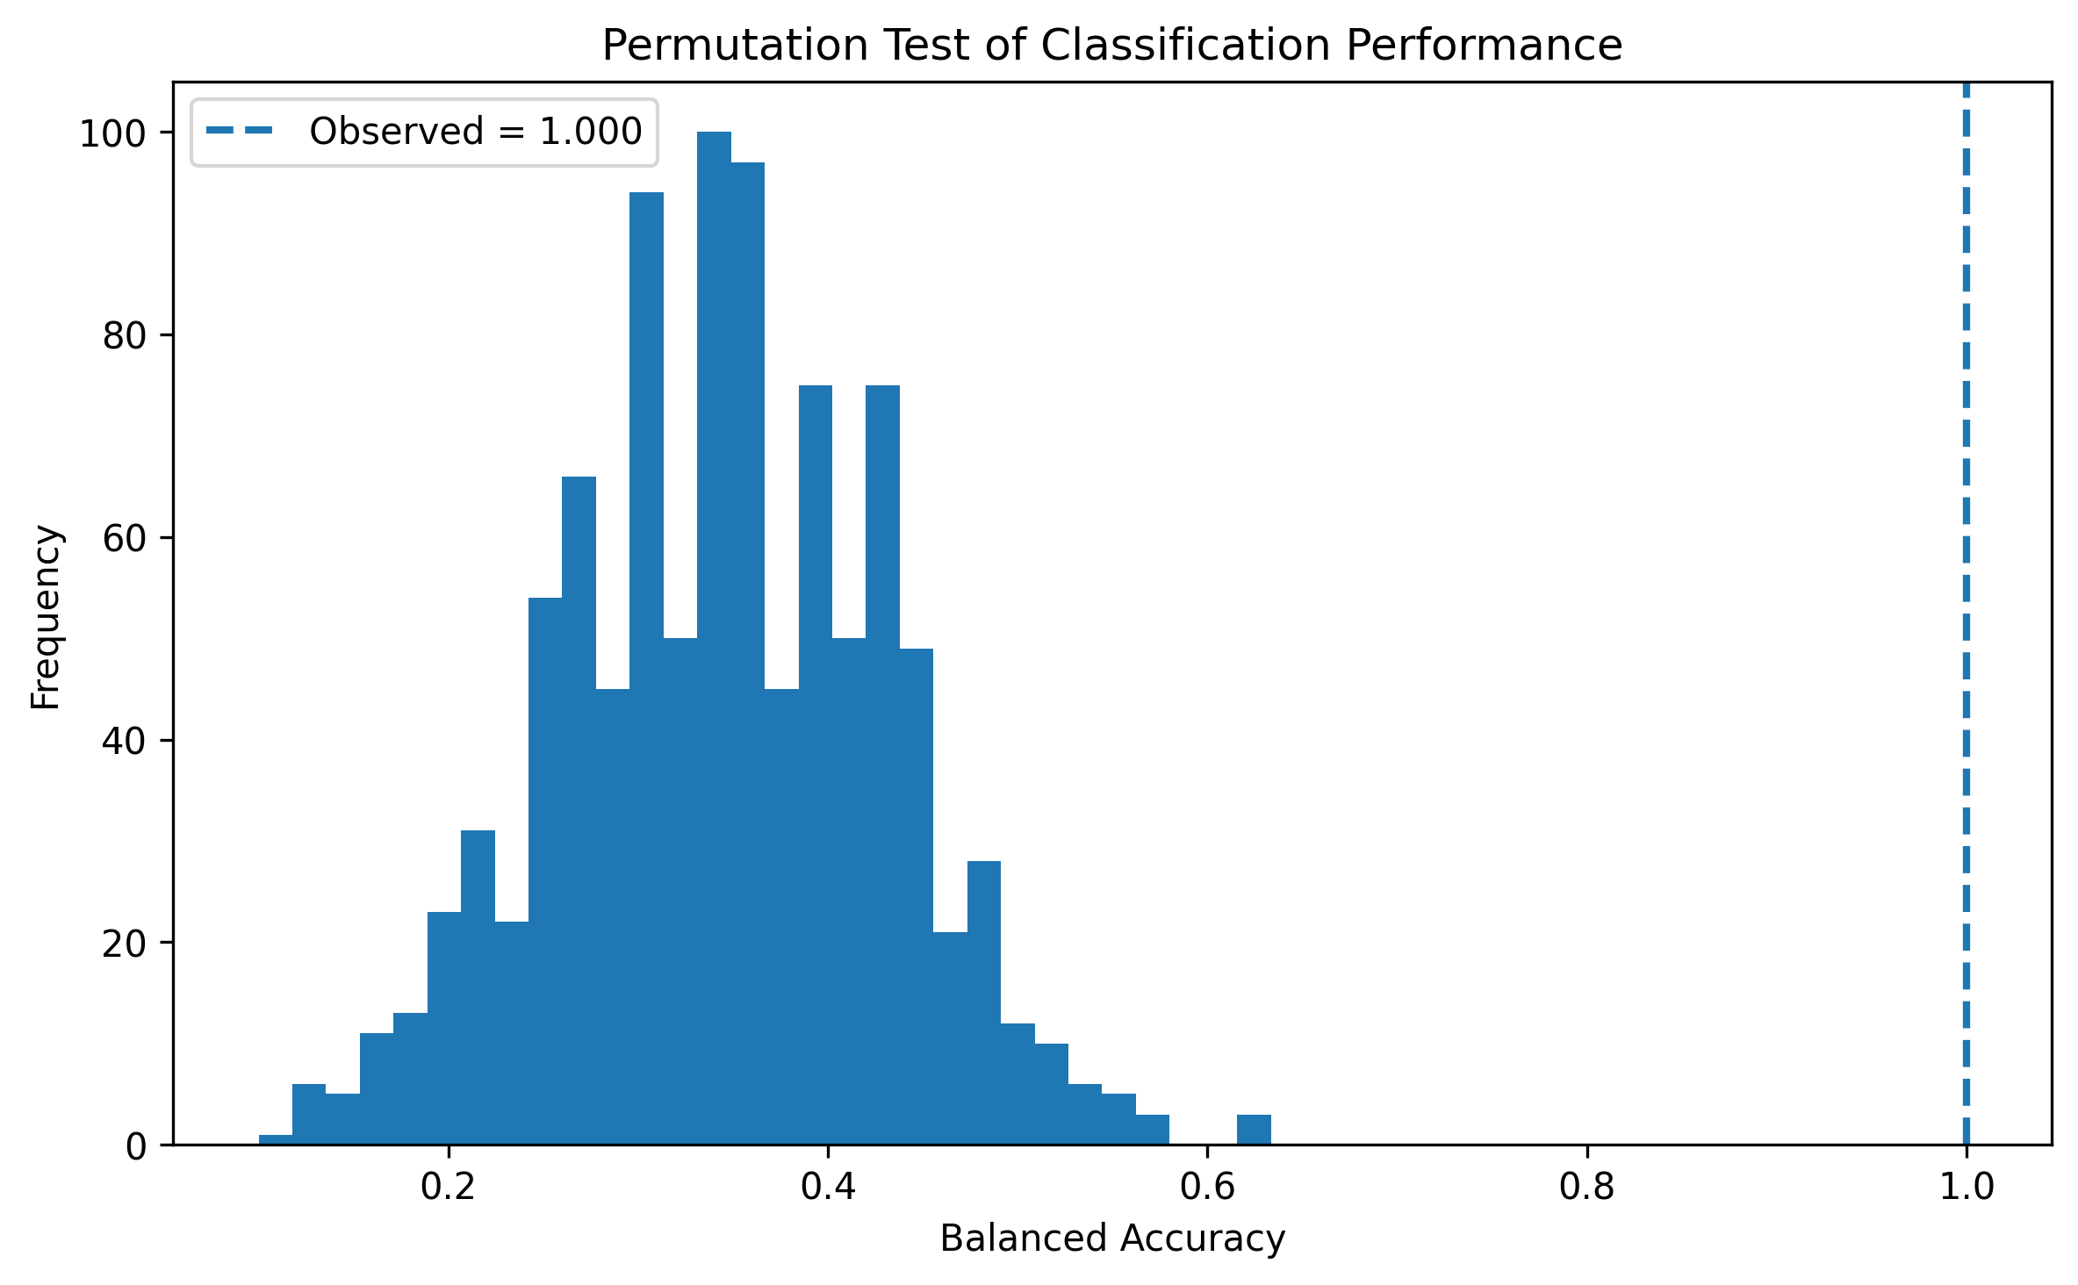

Figure 4. Permutation test of classification performance: observed balanced accuracy (1.000, dashed line) versus the null distribution from 1,000 label permutations (mean = 0.345 ± 0.087).

5.6 SHAP-based explainability

Global SHAP importance (Figure 5) ranked proline (mean |SHAP| ≈ 1.05) marginally above Leaf_Potassium (mean |SHAP| ≈ 0.94) as the dominant predictor overall. Class-conditional SHAP importance (Figure 6) showed that Leaf_Potassium dominated the High_Stress class (mean |SHAP| ≈ 0.34 vs. 0.25 for Proline), whereas Proline dominated the Low_Stress and Moderate_Stress classes (mean |SHAP| ≈ 1.56–1.42 vs ≈ 1.08–1.32 for Leaf_Potassium). The SHAP beeswarm plots (Figures 7–9) show a fully consistent, monotonic directional relationship in every class: high proline values (red) push the model toward High_Stress and away from Low_Stress, while high Leaf_Potassium values (red) push toward Low_Stress and away from High_Stress — exactly the direction expected from the underlying plant physiology, in which osmotic adjustment via proline accumulation and disruption of potassium-dependent stomatal regulation are both well-established drought responses. In isolation, this SHAP pattern is a textbook example of a clean, biologically interpretable explanation, and under most reporting conventions, it would be presented as confirmation that the model has learned a meaningful, trustworthy biomarker relationship.

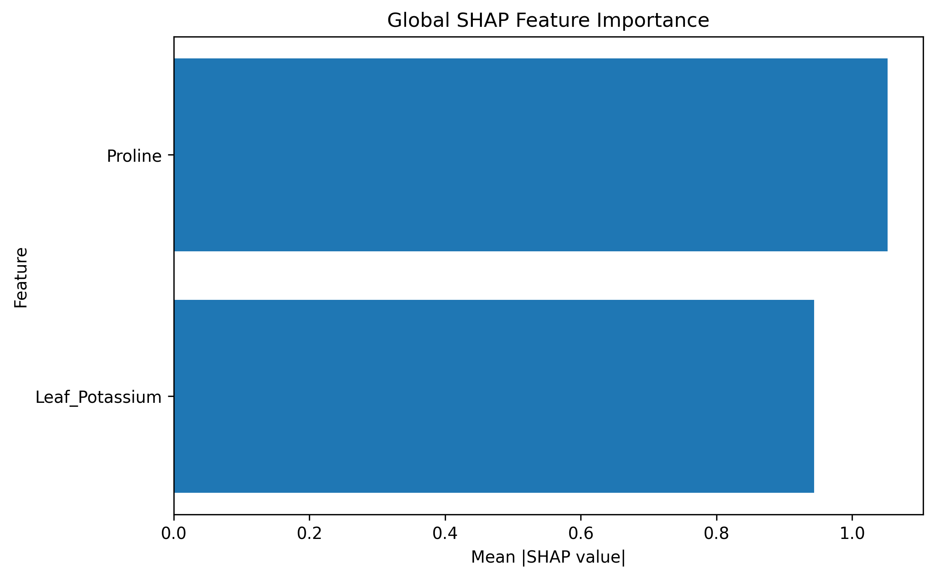

Figure 5. Global SHAP feature importance (mean absolute SHAP value) across all stress classes.

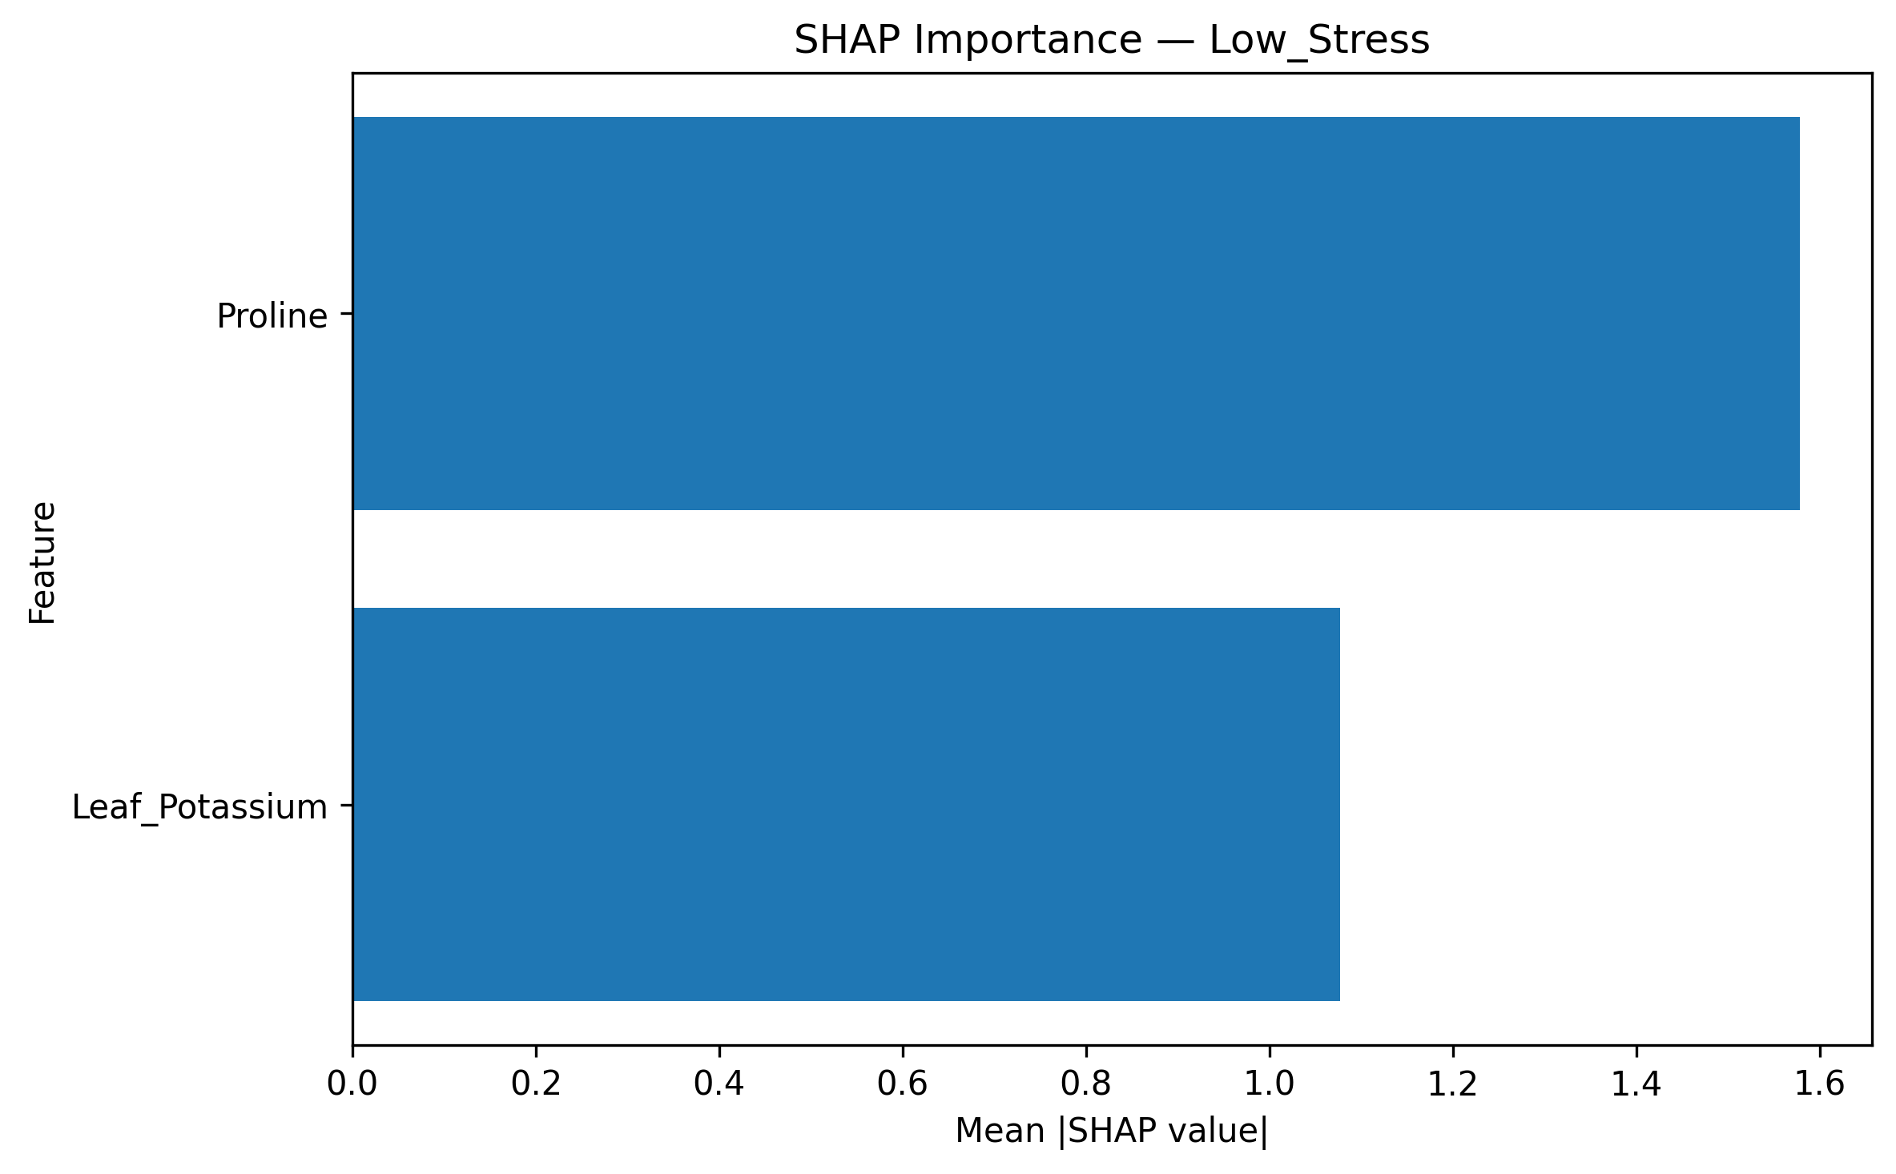

Figure 6a. Class-conditional SHAP importance — Low_Stress.

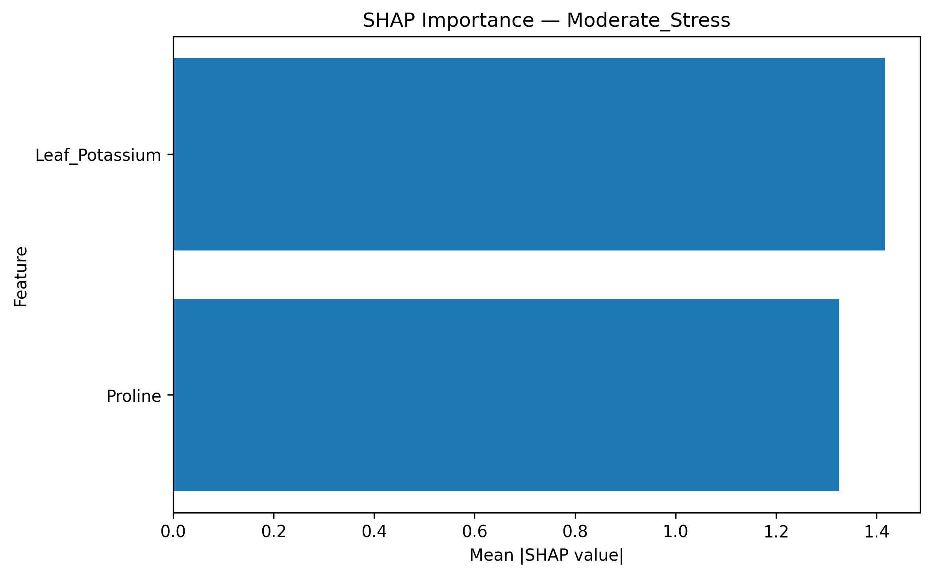

Figure 6b. Class-conditional SHAP importance — Moderate_Stress.

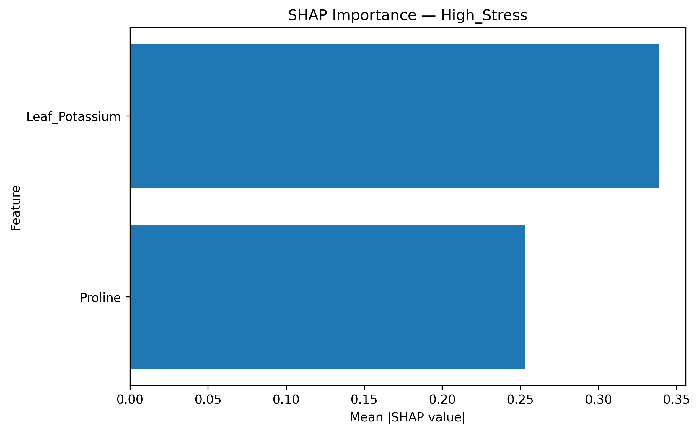

Figure 6c. Class-conditional SHAP importance — High_Stress.

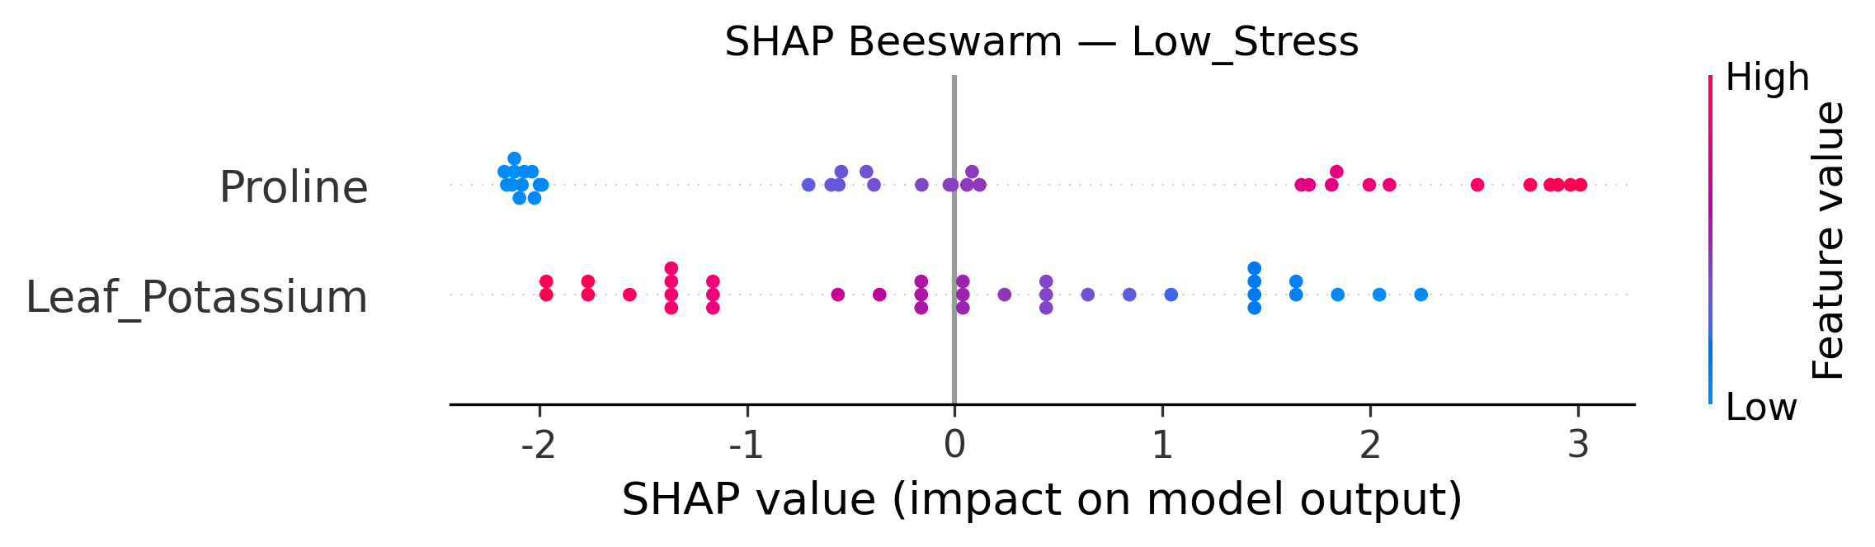

Figure 7. SHAP beeswarm — LowStress class.

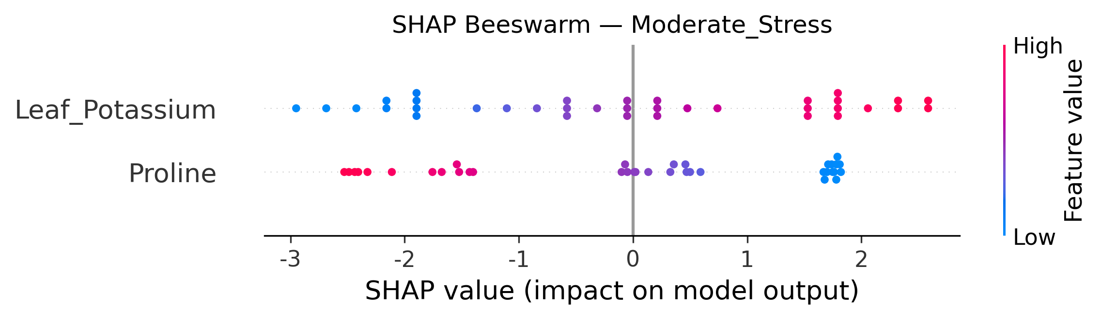

Figure 8. SHAP beeswarm for the Moderate_Stress class.

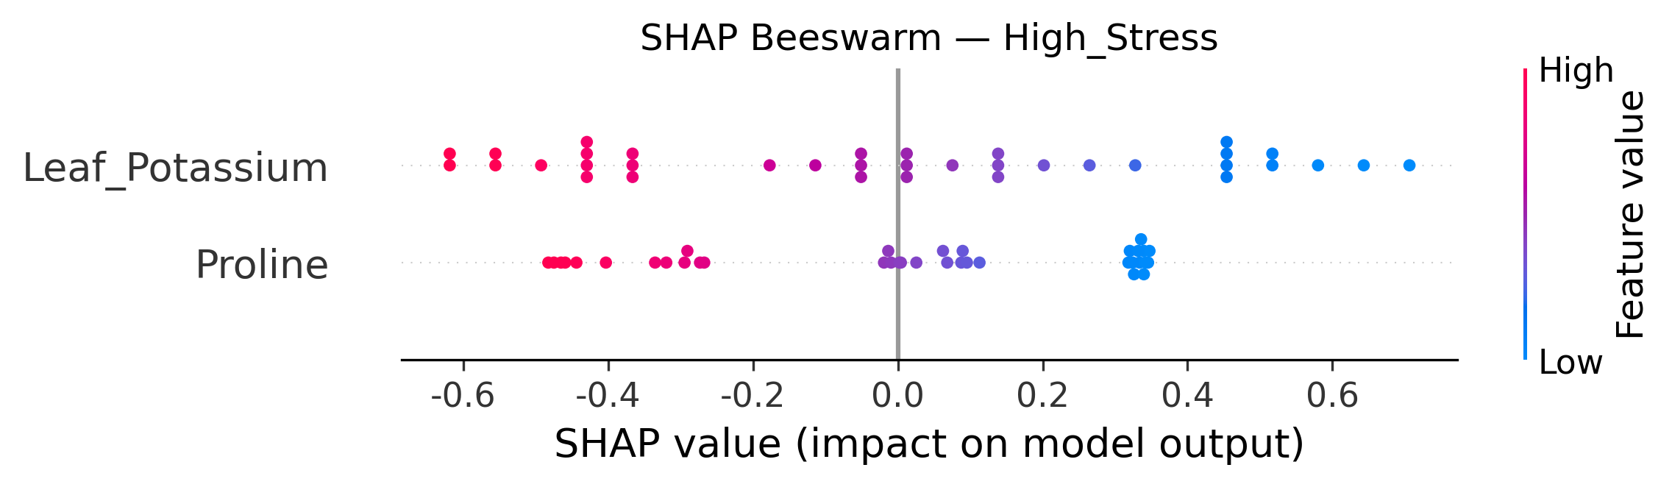

Figure 9. SHAP beeswarm — High_Stress class.

5.7 Critical interpretation: what the perfect accuracy actually reflects

The results in Sections 5.2–5.6 are internally consistent, statistically significant, and biologically plausible at every step, which is precisely what makes this dataset a useful case study in the limits of standard ML validation and explainability reporting. Tracing the target variable back through the data pipeline (irrigation block → stress_condition, Section 4.2) shows that stress_condition is not an independently measured or clinically/physiologically derived diagnosis; it is a deterministic relabeling of the irrigation-block design variable applied at the data-preparation time (I1 → Low_Stress, I2 → Moderate_Stress, I3 → High_Stress, with zero exceptions across all 36 records). Because every biological trait recorded in this trial, not only proline and leaf _Potassium, but also trunk cross-sectional area, bloom timing, fruit weight, and yield, is itself a physiological response to that same irrigation manipulation, essentially any subset of these traits will separate the three irrigation blocks with high fidelity, simply because the blocks differ systematically on nearly every measured variable. This is precisely the pattern documented in the small-sample and data-leakage literature (Section 2.4): with n = 36 and a target that is a direct function of the same experimental block structure that shapes the predictors, k-fold cross-validation, leave-one-stage-out validation, leave-one-replication-out validation, and even permutation testing are all structurally unable to detect the leakage, because none of these schemes ever removes an entire irrigation block from the training data. The only validation scheme that would test genuine, block-independent generalization — training on two irrigation blocks and predicting the stress class of a fully held-out third block, or better, an independently sourced orchard, season, or cultivar not used to define the label at all — was not, and by construction with only three blocks total (one per class) cannot be performed within this dataset.

This does not imply that the physiological findings are false or uninteresting. Proline accumulation and reduced leaf potassium under progressively restricted irrigation are well-established, mechanistically grounded drought responses independently corroborated in the broader literature (Section 2.1). The Kruskal–Wallis, Spearman, and SHAP results in Sections 5.2 and 5.6 are legitimate, statistically sound descriptions of how strongly these two traits differed across the three irrigation treatments in this trial. The results do not support the stronger claim implied by the headline '100% cross-validated accuracy for early water-stress detection': that this pipeline constitutes a validated diagnostic tool capable of classifying the water-stress status of a kiwifruit vine not already known to belong to one of the three specific irrigation blocks used to build the model. The distinction is important both practically and statistically; a grower cannot use this model to diagnose an unknown vine's stress status in the field, because the model has only ever learned to distinguish three predefined treatment groups from each other, not to recognize the physiological signature of water stress in general. Therefore, we report the SHAP-identified biomarkers (Proline, Leaf_Potassium) as strong, literature-consistent candidates for a future diagnostic model, while explicitly declining to claim that the present classification pipeline, as validated, constitutes such a model.

This finding also illustrates a broader point regarding the role of explainability in agricultural ML. SHAP correctly and faithfully described what the classifiers learned — a strong, monotonic, and physiologically sensible relationship between two biomarkers and the assigned stress class. It could not, by itself, distinguish between two very different underlying scenarios that produce an identical SHAP signature: (a) the biomarkers genuinely and independently predict water-stress severity in a way that would generalize to a new vine, or (b) the biomarkers and the label are both downstream consequences of the same treatment assignment, so the SHAP relationship is real but non-generalizing outside the specific blocks studied. Disambiguating these two scenarios required tracing the data-generation pipeline back to its source — a step that lies outside the scope of any purely model-internal explainability or validation technique, and that we recommend as a mandatory, explicit component of any future kiwifruit (or comparable small-block agronomic) water-stress ML study.

6. Conclusion and Future Work

This study developed and rigorously evaluated an explainable machine learning pipeline for classifying kiwifruit water-stress severity from two physiological biomarkers, Proline and Leaf_Potassium, achieving perfect five-fold cross-validated performance across five structurally different classifiers (accuracy = balanced accuracy = macro-F1 = MCC = 1.00), confirmed significant against a 1,000-iteration permutation null (p = 0.001), and explained via SHAP with directionally and biologically consistent feature attributions in every stress class. Rather than reporting this as evidence of a validated diagnostic tool, we used the same explainability and validation machinery, together with an audit of the target-construction pipeline, to show that the near-perfect classification reflects the deterministic relabeling of the trial's irrigation-block design variable as the stress-severity target, combined with the fact that essentially every physiological trait in a small, block-designed trial is a downstream consequence of that same treatment assignment. Standard k-fold, leave-one-stage-out, and leave-one-replication-out cross-validation, and even permutation testing, are all structurally incapable of detecting this specific failure mode because none of them removes an entire treatment block from model training.

Three concrete methodological conclusions can be drawn. First, explainability should be applied as an audit tool before and after results are reported. SHAP directional consistency and global importance rankings are necessary but not sufficient evidence of a generalizable biomarker relationship and should always be paired with an explicit trace of how the classification target was constructed relative to the experimental design. Second, for factorially block-designed agronomic trials, the single most informative validation scheme — holding out an entire treatment block, not merely a stage or replicate — is also the one for which most trials are structurally too small to support, which argues for either substantially larger multi-orchard/multi-season trials or, alternatively, continuous rather than treatment-derived stress-severity targets (e.g., a threshold defined from an independent reference measurement such as stem water potential, following Patseas et al., 2026) that are not deterministic functions of the treatment label. Third, univariate effect-size decomposition (Kruskal–Wallis η², Spearman ρ) should be reported alongside multivariate classifier performance as a routine diagnostic, since a single feature reaching η² > 0.9 and |ρ| > 0.9 is itself a strong signal that any multivariate classifier’s ‘perfect' performance may be entirely attributable to that one feature's near-total confounding with the experimental block, rather than genuinely complementary multivariate information.

Future work should pursue three directions that build directly on this audit. First, independent field validation using multiple orchards, seasons, and/or cultivars, with the stress severity target derived from a physiological reference threshold measured independently of irrigation-block assignment (for example, a stem- or trunk-water-potential cut-off following the approach of Patseas et al., 2026), would allow a genuine test of whether Proline and Leaf_Potassium generalize as early warning biomarkers beyond the specific treatment blocks studied here. Second, continuous sensor integration, which combines the biochemical assays used here with continuously logged sap flow, trunk microtensiometry, and canopy spectral reflectance (Kokkotos et al., 2025; Lakso et al., 2022; Garofalo et al., 2024), would enable regression-based, continuous stress-severity estimation rather than a small number of treatment-derived discrete classes, reducing the risk of target circularity by construction. Third, block-held-out and multi-site cross-validation protocols, together with routine reporting of permutation tests and SHAP-based design audits of the kind demonstrated in this study, should become standard practice for small-n, block-designed agricultural ML studies, both in kiwifruit physiology and, more broadly, wherever a classification target risks being a disguised proxy for the experimental treatment that also generated the predictor variables.

References
Conesa, M. R. (2023). https://doi.org/10.3389/fpls.2023.1123045
Porras-Jorge, R., & Aguilar, J. M. (2025). https://doi.org/10.3390/plants14020164

